**Working on Churn-out rate:**

**Visualizing AB test**

**Predicting the Churn-out rate of employees of a bank using Tableau:**

**About data : Source:Internet Dummy data only for study purpose.**

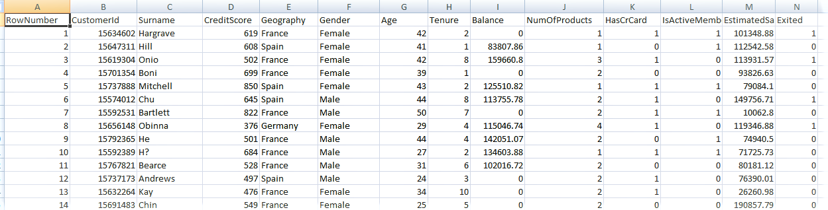

**As we can see our dataset contains the columns as shown above , The bank wants to know why the employees leaving there bank gradually? So they may took a snapshot of a population to work it out.**

**Lets use Tableau:** 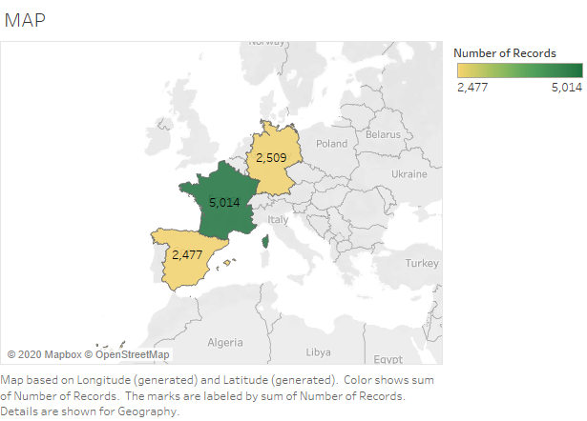

**From the map we get to know France ,Germany,Spain had 5014,2509,2477 records respectively.**

**Lets work on Gender Attribute:**

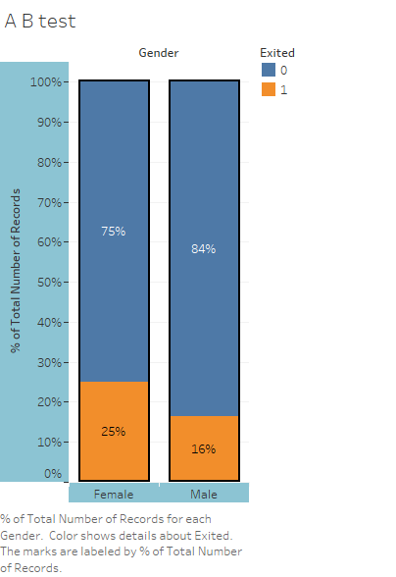

**As we take on gender attribute it is devided in to Male&Female employees staying in the bank and Not staying in the bank. But right know we are confused a bit by looking bar chart, we are not able to conclude 25% of female employees leaving or staying in the bank, Lets clear that.**

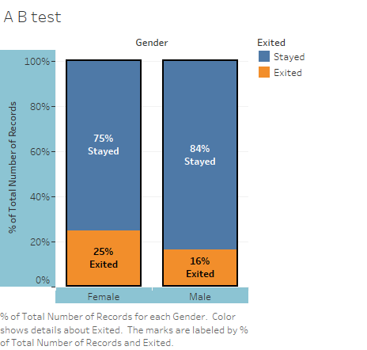**By using Aliases we can make our prediction even better. Looks like the Female employees are leaving the bank more compared to the male employees. Lets go further.**

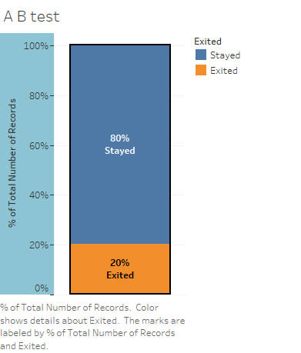

**The Barplot tells us that 20% of employees are leaving the company, which is really a big deal.**

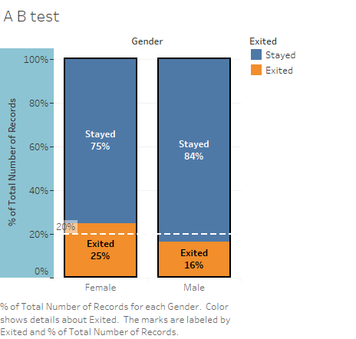

**I just added a Reference Line just to have some threshold, Reference drawn here is just a common line, Not average or median . Looks like there is a small percentage of differences in people leaving the company(bank) or staying in.**

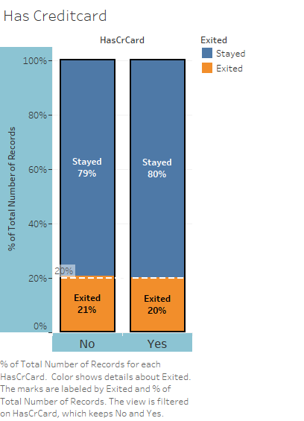

**Lets check leaving the bank has it anything do with the attribute: Has Credtcard ?**

**21% of people they don’t have credicard so they exited, and 20% of people they have credicard and they stayed. What happened to the 1% [21-20] of people? Where they gone missing in the data?.Lets dive in.**

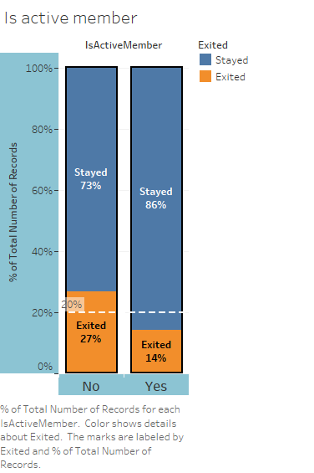

**27% of people they are not active member and they left the bank.**

**14% of the people they are actve member of the bank eventhough they left.**

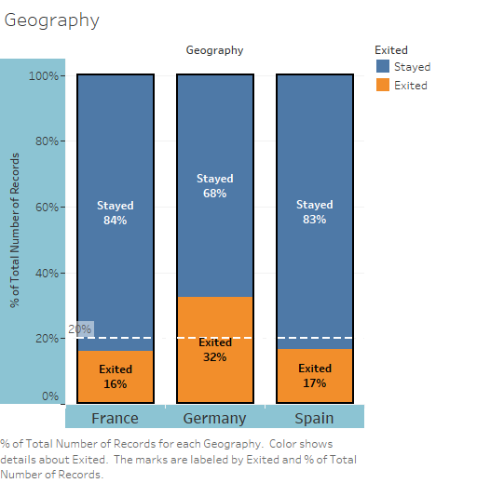

**Employees of the Germany are leaving the bank more compared to the France and Spain,**

**Bank has to take initiative in Germany more compared to the 2 other countrys.**

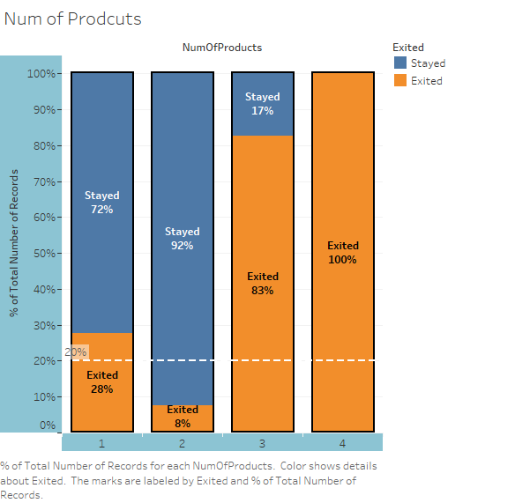

**When i check the attribute:Num of products its look like more the product more exit rate**

**In 4th section people who has more than 4 product all looks like they exited the company,**

**Or this may wrong also, there may be error in the sample of data.**

**Lets go and check the data.**

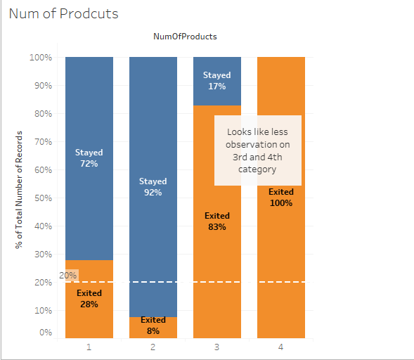

**Annotating my observation for future reference.**

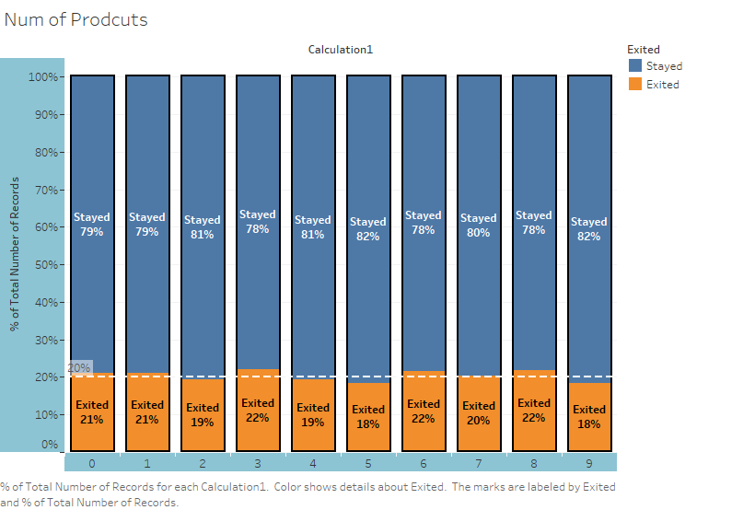

**This visualization tells me that data is uniformly distributed,No Skewness and Kurtosis found, Data lies on average of ±20%. So prediction is, our data is Just fine.**

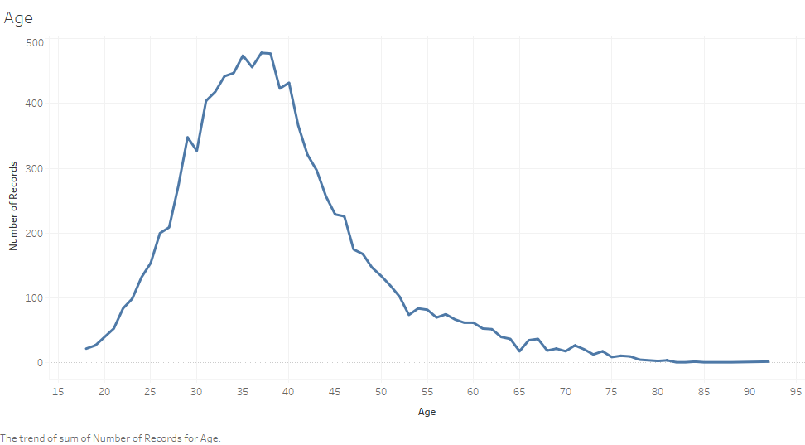

**Checking attribute :Age it looks like there is more spiky in our data, its not good for the visualizarion**

**By this plot we can conclude that there are more people in the range of 35 to 40 age. And vey less people in the age of 90’s. Lets make this graph much smoother.**

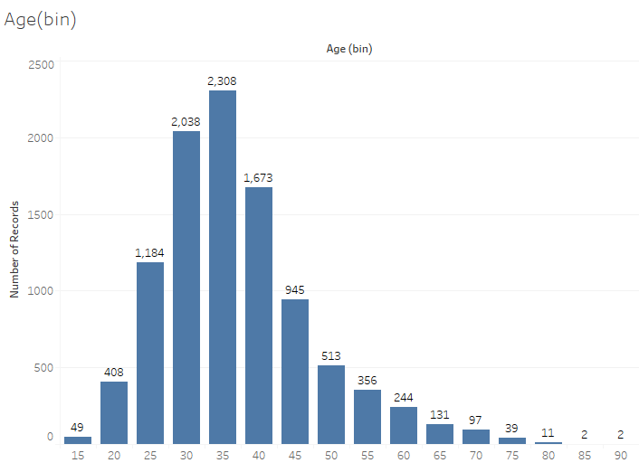

**Graph is smoothened and easy to visualize, this plot is created by taking age as 5 year bins.**

**Plot looks like Right Skewed.**

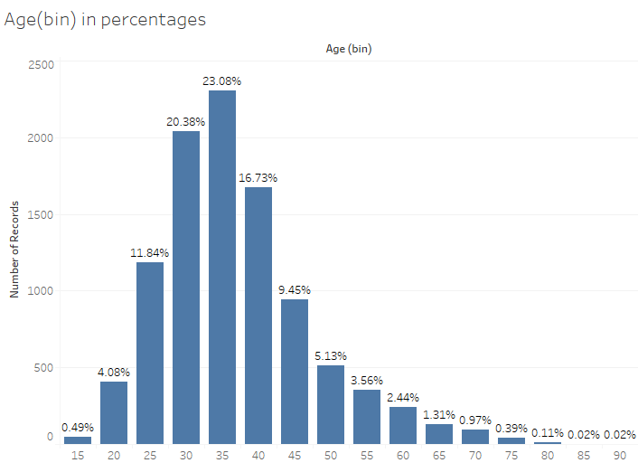

**Difference between previous plot and this plot is, it had percentages. 48% of the people in this company are in between the age range 30 to 40, they are the assets of this company.**

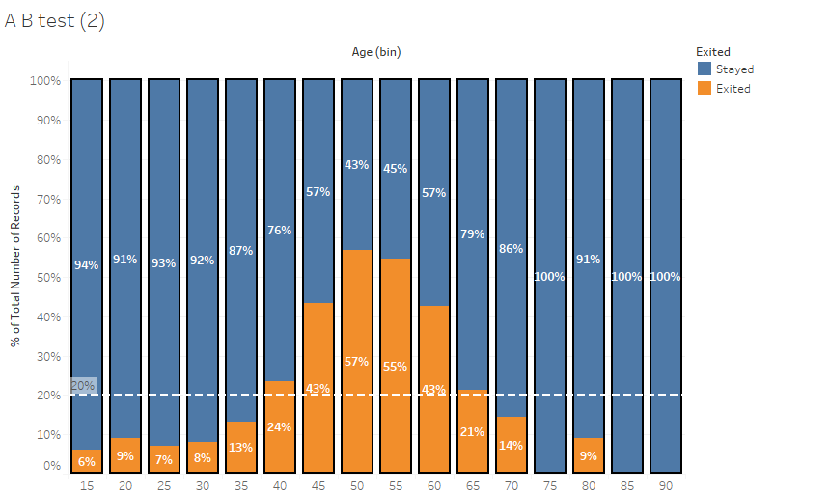

**So I am checking the age bins on A-B test of percentage of people leaving and staying in the bank**

**The people who had age of 45 to 60 are more likely to l.eave the bank , We can analyse like this more the experience means better carrear opportunity. The age of 75,85,90 they looks suspicious no observation of people leaving the company? Looks suspicious isn’t it?.**

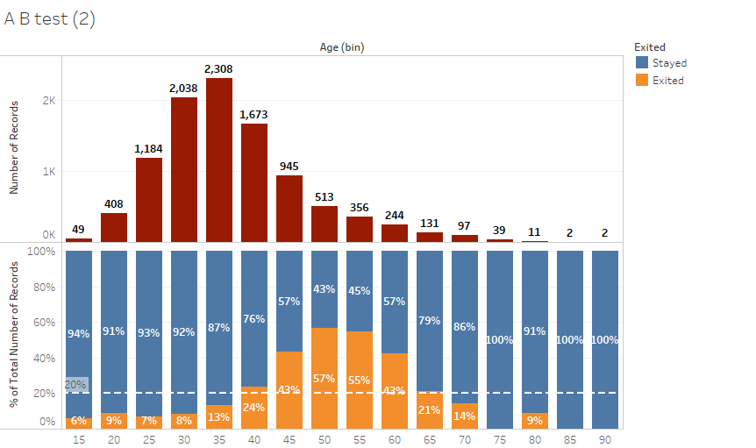

**Combined chart: The last records i.e 75,85,90, they have the observation 39,2,2 respectively which are very less observations compared to the other.**

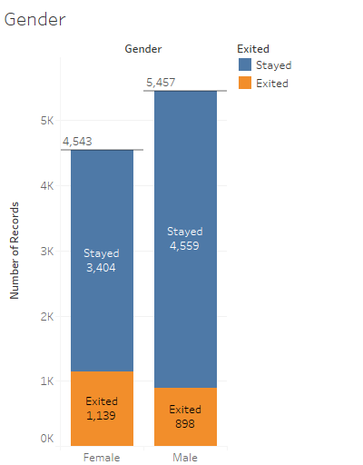

**Lets check my samples are statistically significant are not , Lets check on by CHI-SQUARED test.**

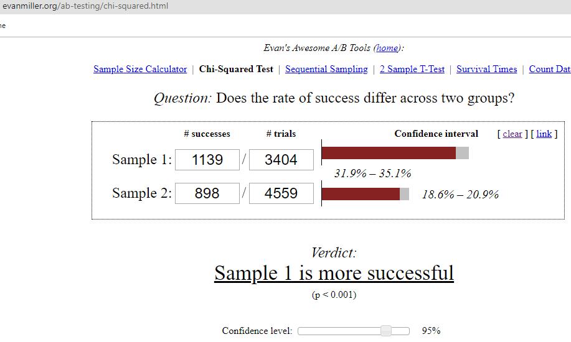

**CHI-SQUARED test, here its saying Sample-1 {i.e above picture 1,139 Female exited} is more Significant compared to Sample-2 also P-values is below 0.05 which proves again.**

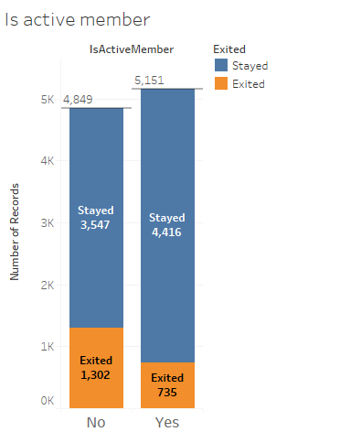

**Lets do CHI-SQUARED test on Active member.**

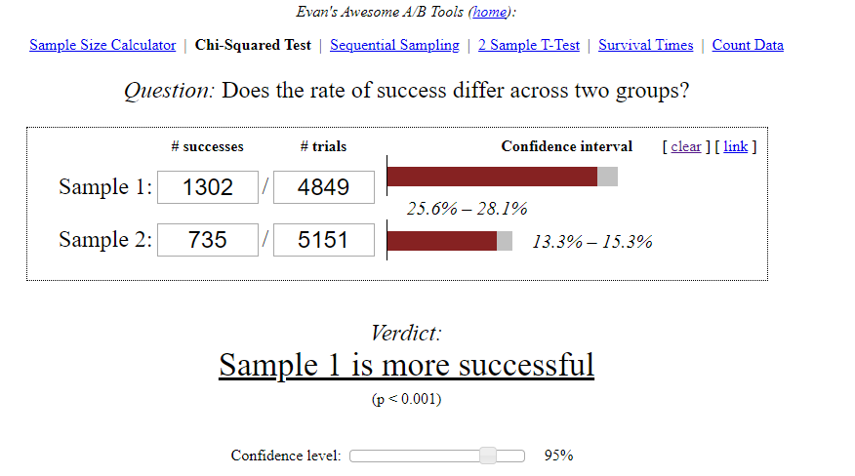

**Sample 1 is more significant P-values=0.0015.**

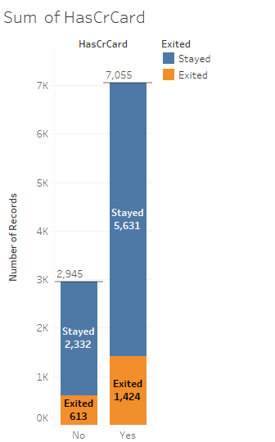

**CHI-SQUARE on attribute: HasCrCard.**

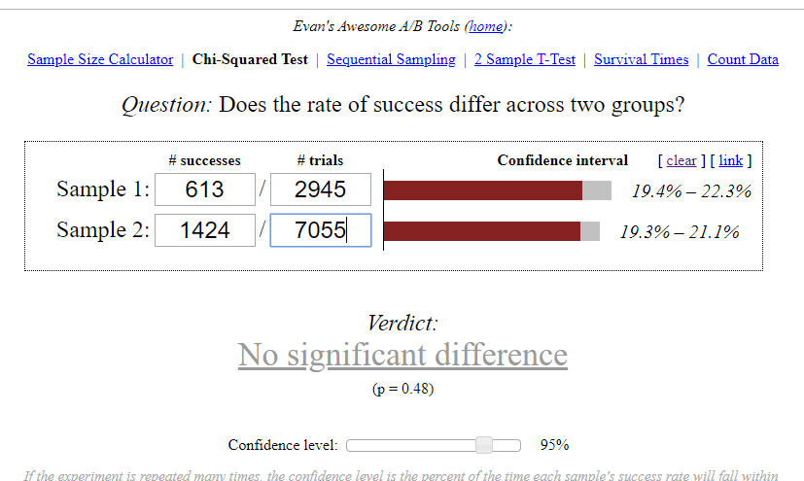

**Person has credit card or not, Is not Significant enough in consideri ng during our modeling**

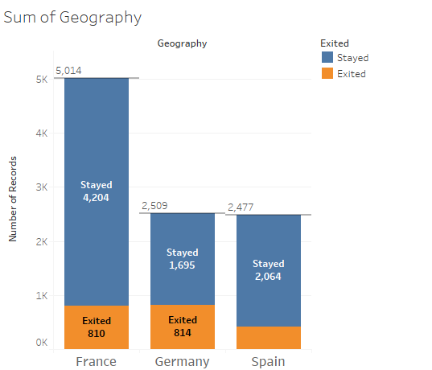

**Lets Run CHI-SQUARED test on Geography.**

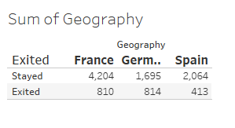

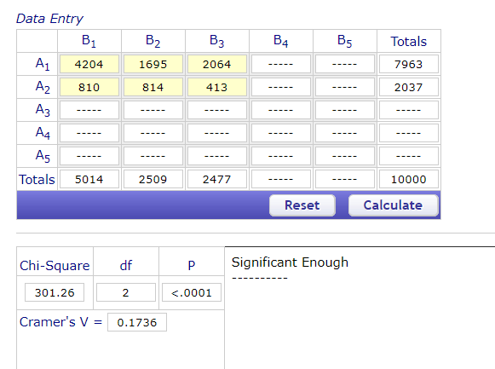

**Chi-square test shows us that it is significant enough.**

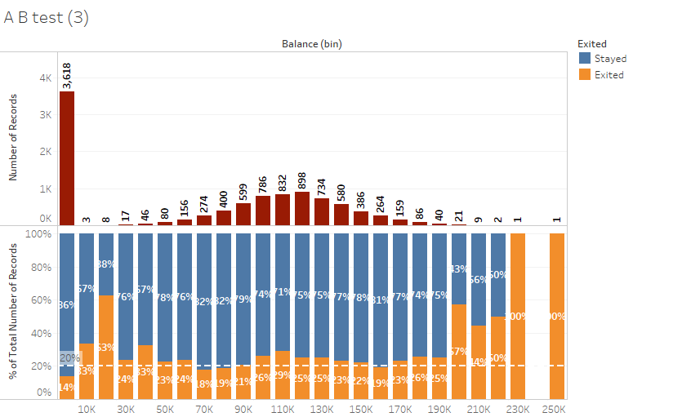 **Lets check on the attribute:balance does it affect on people leaving or staying in the company**

**There is one sample of record in balance(bin) which is stand tall lets check out its data.Only one sample pf observation had balance 3618 rest are all zero, so its irrelevant here lets remove it to get uniform distribution**

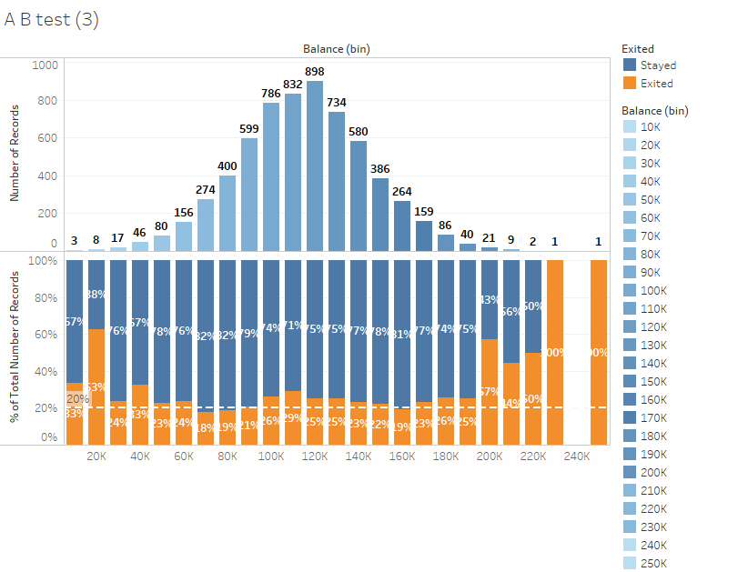

**So we got uniform distribution, The probability of people leaving the company is looks like just above and below the standard threshold which is fine.**

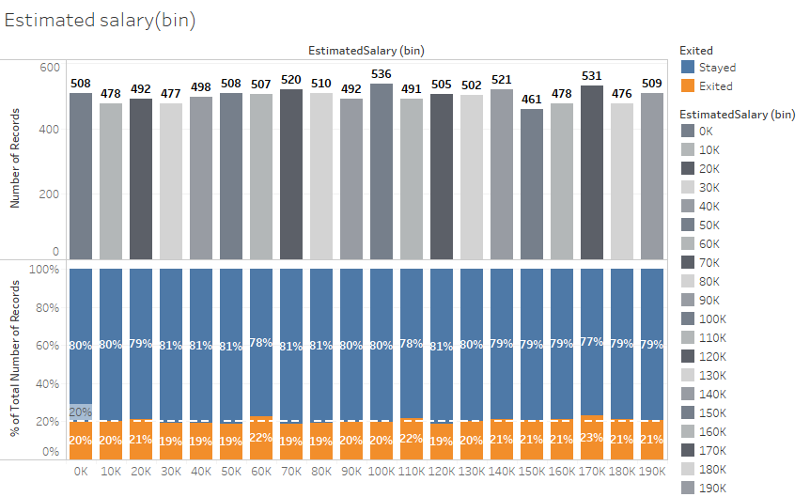

**Observe the Estimated-salary(bin) there is almost equal number of records in every bin,Persons earning 180K to 190K and 10K to 20K is that same?? There may be a chance that**